CASTLEMAINE & DISTRICT
AGRICULTURAL SOCIETY INC
CELEBRATING 171st Anniversary Est 1854
*ANNUAL
FLEECE & SHEEP
COMPETITION
31st Oct and 1st Nov 2025
At CAMP RESERVE CASTLEMAINE
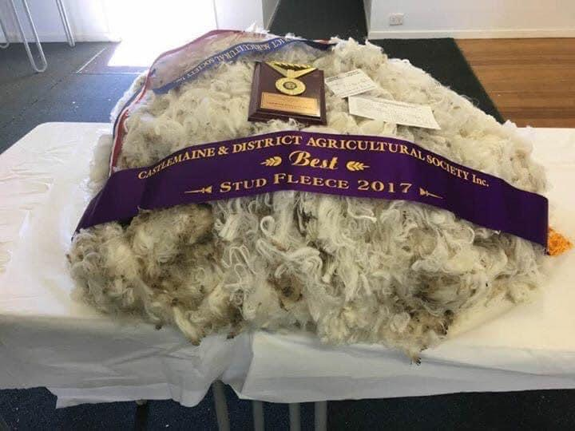
SHEEP AND WOOL SECTIONS 2025

SUPREME FLEECE OF SHOW- Memorial Award in honour of our Former President. Vice President Chief Wool and Sheep Steward

N B FLANAGAN MEMORIAL AWARD
Show Secretary/Life Member: Debbie Hamilton- Office from 20th Oct- or Mobile -0413339058- email hamiltondebbie28@yahoo.com.au
Post all Entries to Post Office Box 65, Castlemaine.3450 Vic
All Exhibits must be delivered to Show grounds (Camp Reserve) No later than 4pm on 25th October 2025
*CHIEF STEWARD MR LEIGH TONKIN
Vice President-Life Member -Co Treasurer Ph 0428102909
Arrangements can be made with Leigh or Secretary Deb to have your fleeces collected. Or drop them to the Show office.
Chief Steward
Leigh Tonkin
Sen Vice President/ Co Treasurer/Life Member
Phone-0428102909
Sincere respect for our Past President and Life Member
Noel Flanagan whom past away 14 April 2024

Fleeces from Middle Eastern Breeds will not be accepted.

. SHOW Date 31st Oct 2025

PLEASE PLACE A TAG WITH YOUR NAME ON EACH FLEECE.

SUPREME FLEECE OF SHOW- SASH-TROPHY & $50.00
BEST COMMERCIAL FLEECE-SASH- -$40
MOST SUCCESSFUL EXHIBITOR –SASH
MOST STYLISH FLEECE SASH
MOST VALUABLE FLEECE excluding Rams Fleece SASH
BEST NON-MERINO FLEECE-SASH
BEST HERITAGE FLEECE -SASH

JUDGING FLEECE SECTION-

$3.00 per fleece per class- 1st Prize $5 2nd Prize $3.00 ribbons to third place
All prize money to be collected at the secretary’s office after 3.pm Sat 1st Nov 2025

- Merino Commercial Ewe or Wether- 15,5- & Finer
- Merino Stud Ram 15.5 Finer Extra Ultra Fine
- Merino Stud Ewe or Wether -15.5 and Finer Extra Ultra Fine
- Merino Commercial Ewe or Wether-15.6-17.5 Ultra Fine
- Merino Stud Ram- Ultra Fine-15.6-17.5
- Merino Stud Ewe - Ultra Fine-15.6-17..5
- Merino Stud Ram- Super Fine 17.6-19.5
- Merino Stud Ewe or Wether Superfine 17.6-19.5
- Merino Commercial Ewe or Whether-super Fine-17.6-.19.5
- Merino Stud Ram- Fine-19.6-21.5
- Merino Stud Ewe or Wether Fine 19.6-21.5
- Merino Commercial Ewe or Wether- Fine-19.6-21.5
- Merino Stud Ram Medium 21.6+ stronger
- Merino Stud Ewe or Wether -Medium 21.6 + stronger
- Merino Commercial Ewe or Wether- Medium -21.6 + stronger
- Corriedale Ram
- Corriedale Ewe or Wether
- Crossbred Fleece
- Heritage Fleece- Long Wool
- Heritage Fleece-Short Wool
- Pets Fleece from a claimed to be pet sheep
-

SHEEP SECTION_ Open.

JUDGING SHEEP SECTION ; To Confirm

Please state BREED on the entry Form. All Sheep to have JD & Brucellosis and Johnes desease negative result forms from a veterinarian attached with entry forms.
Non-Accredited Sheep will not be accepted.
Pic Numbers and ID Tags.
We will be entering all sheep to the Department of Agriculture.
Entries $3.00 per class. Prize money $5 -first -$3 second
$15.00 to each Champion. $10.00 Reserve Champion each Breed.
Entries close 28th Oct 2025 SHOW DAY IS 1st Nov 2025 All sheep to be penned by 10 am judging starts 10.30am
All CHAMPIONS AND RESERVES WILL RECEIVE A SASH. Ribbons to third place.
- Ram over one ½ years
- Ewe over one ½ years
- Ram under one ½ years
- Ewe under one ½ years
- Group Ram & 2 Ewes
- Ewe with Lamb at foot
- Interbreed Ram No restrictions on distance.
- Interbreed Ewe No restrictions on distance

Exhibitor’s passes will be issued to those exhibitors with ten or more entries.
Gate Entry Child yrs. to 16 years $8.00 entry-Adults $15.00- Pens -$8.00

Fleeces will be displayed in the Main Pavilion at the front of Grounds.
7.30pm.Friday evening. 31st Oct 2025 Saturday 10.30am 1st Nov 25
Friday night’s activities include Street Parade at 6. 30pm.Fire Works Display at approx. 10 pm.Wood Chop Event 6.30pm.. Craft- Cooking- Horticulture- Side Shows. FOOD GALORE
Saturday Animal Day. Pet Show’ 11am Judged by Mayor Rosie Annear and Stewarded by MAAW= Sheep Rare Breeds,
Muddy Gumboots pet farm animal nursery
SPONSORED By CANTWELL PROPERTY
gate entry-$15,00 adults-Pens $8. Child over yrs. up to 16 years $8.00 pass
Proof of student pass $8. Child yrs. and under FREE ENTRY

DON SMALLGOODS OUR VERY OWN BACON FACTORY IN CASTLEMAINE SPONSORING THE COOKING SECTION. GREAT PRIZES -NO FEE FOR COMPETITION
JUST ENTER 5 COOKING ENTRIES FREE & YOU GET FREE ENTRY TO THE SHOW AS WELL.

